Nakayoshi Gakko
Pick up Bundle of Bamboo

Arts and Crafts Committee

Class: Kuma

Project: Bamboo Chimes

Material: Bamboo

Qty. Needed: 18 each of 3”, 4”, 5”, 6”, and 9”

Instructions: Cut bamboo into lengths: 3”, 4”, 5”, 6”, and 9”. For the 9”–length bamboo rod, drill 6 evenly spaced 1/8” holes. (Holes at each end are for securing a handle for the chimes. Holes in the middle are to hang the 3”, 4”, 5”, and 6” bamboo rods.) Drill 1/8” holes near the top of each of the 3”, 4”, 5” and 6” rods so that there is a way to attach the string. Please make sure holes go through the bamboo completely (two sides). See picture below.
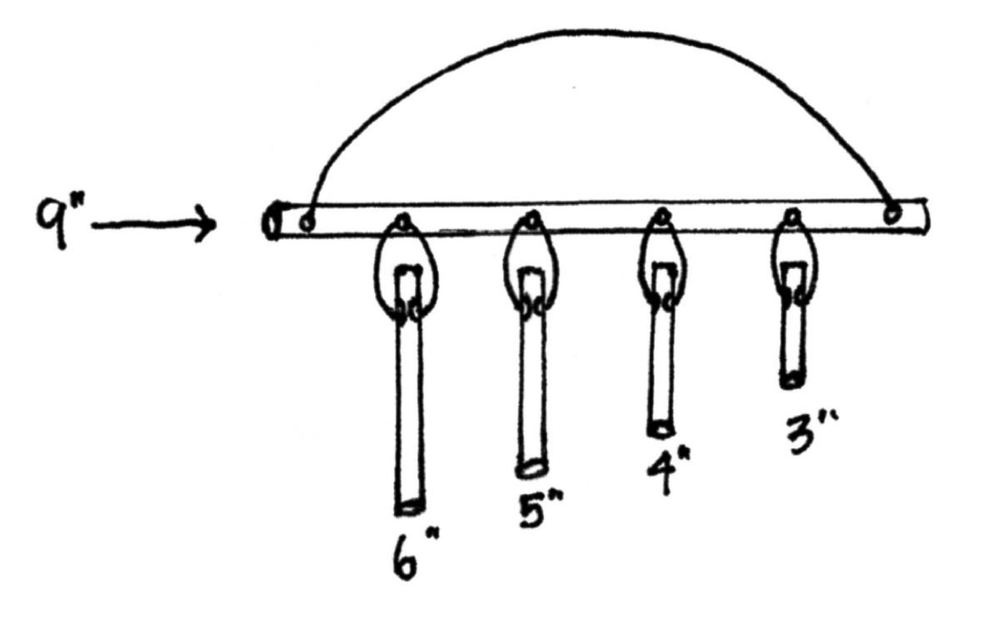
Due Date: Bring completed project with you on Maintenance I Day prior to the start of session. Please return sample and any unused supplies.

Thank you in advance for your help. ☺

